**DAILY ONLINE ACTIVITIES SUMMARY**

|  |  |  |  |  |  |  |  |  |
| --- | --- | --- | --- | --- | --- | --- | --- | --- |
| **Date:** | **31/05/2020** | | | | | **Name:** | **KHATHEEJA SAFREENA** | |
| **Sem & Sec** | **IV sem & A section** | | | | | **USN:** | **4AL18CS0037** | |
| **Online Test Summary** | | | | | | | | |
| **Subject** | | **-** | | | | | | |
| **Max. Marks** | | **30** | | **Score** | | | **-** | |
| **Certification Course Summary** | | | | | | | | |
| **Course** | **PHYTON WITH MACHINE LEARNING.** | | | | | | | |
| **Certificate Provider** | | | **Greatlearning academy** | | **Duration** | | | **10 hours** |
| **Coding Challenges** | | | | | | | | |
| **Problem Statement1:** Write a Java program to calculate nPr. | | | | | | | | |
| **Status: Executed** | | | | | | | | |
| **Uploaded the report in Github** | | | | | **YES** | | | |
| **If yes Repository** | | | | | **[http://github.com/shafreenasharief/lockdown-coding](http://github.com/shafreenasharief/lockdown-coding" \o "http://github.com/shafreenasharief/lockdown-coding)** | | | |
| **Uploaded the report in slack** | | | | | **YES** | | | |

Online Test Summary: No internals conducted today.

Online Certification Course Summary: In today’s session I have learnt every modules and also I completed quiz assessment

**ONLINE CERTIFICATION COURSE SUMMARY:**

* Today I'm doing a course on MACHINE LEARNING WITH PYTHON. It is a 10 hours course. I completed 3 module. Which explains about Anaconda installation and intro to juypter, juypter notebook and shortcuts,Data structure on-hand. I attempted quiz which gave me a clear veiw about the topics that were thought and discussed.
* It consists of 30 modules including assessments.

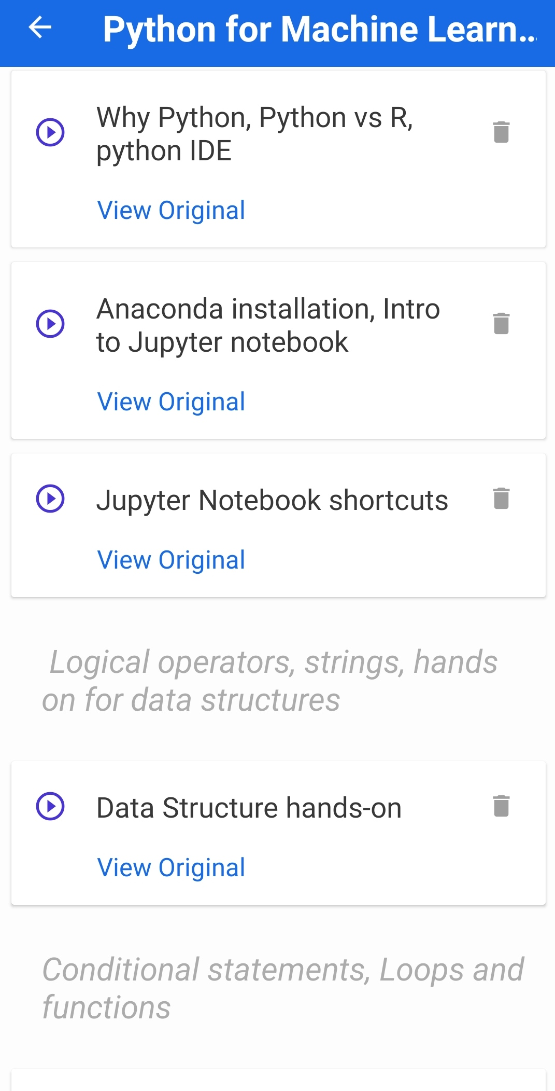

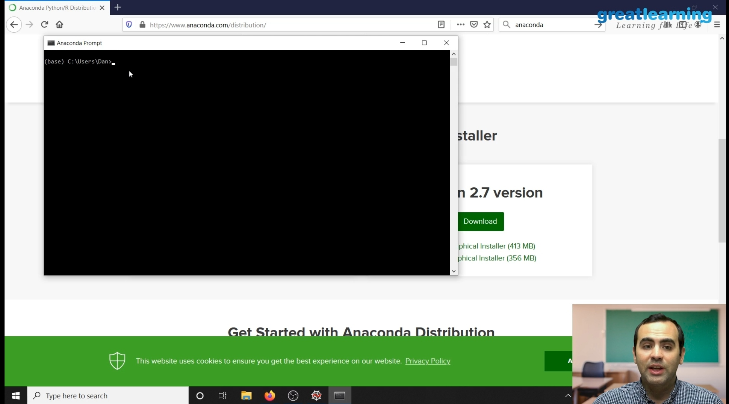

These are the Snap shots of today’s sessions.

**ONLINE CODING CHALLENGE:**

**Today I had received one program from prof. Shilpa CSE Dept. The program is mentioned above in the coding challenges(pg.01). I have also uploaded it to my Github repository.**

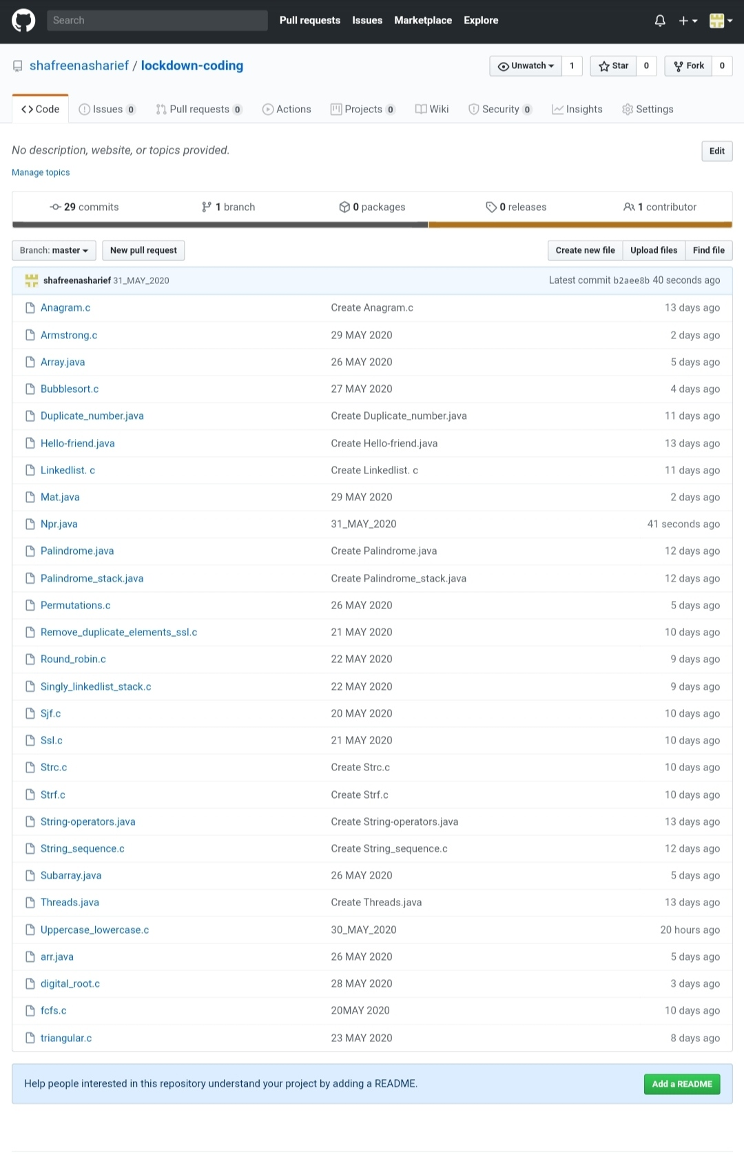

**This is the snap shot of my Github repository** were I have uploaded the code. File name is npr.java

[http://github.com/shafreenasharief/lockdown-coding](http://github.com/shafreenasharief/lockdown-coding" \o "http://github.com/shafreenasharief/lockdown-coding)

[http://github.com/shafreenasharief/locked-down--certification-course](http://github.com/shafreenasharief/locked-down--certification-course" \o "http://github.com/shafreenasharief/locked-down--certification-course)

[http://github.com/shafreenasharief/Daily_Report](http://github.com/shafreenasharief/Daily_Report" \o "http://github.com/shafreenasharief/Daily_Report)